**Part 1**

As if we don't know the specific current rating for our LED, a safe starting point is to use a 220-ohm resistor. This common value limits the current to about 10-20 mA for a typical LED, which is within the safe operating range for most LEDs. Set the power supply to a voltage higher than the expected forward voltage of the LED (usually around 2V for red LEDs, up to around 3.3V for blue or white LEDs). Make sure not to exceed the maximum voltage rating of the LED. Use a multimeter set to measure voltage. Connect the multimeter's leads to the anode and cathode of the LED (in parallel with the LED).

Turn on the power supply. The LED should light up. Read the voltage value on the multimeter; this is the voltage drop across the LED.

**Calculate Current through the LED:** If we know the maximum current of digital output pin can supply, we can use that to determine the safe current for the LED. For example, if the maximum current is 20mA, we might limit the current through the LED to 10mA for the safety and longevity of the LED.

**Calculate the Resistor Value:** Use Ohm's law to calculate the resistor value needed to achieve the desired current through the LED. We will subtract the voltage drop across the LED from the voltage of the digital output pin to find the voltage across the resistor. Then, divide that voltage by the desired current to find the resistor value.

For example, if the output pin provides 5V, your LED has a forward voltage of 2V, and we want to run the LED at 10mA (0.01A), the voltage across the resistor would be 5V−2V=3V. The resistor value would be R=V/I=3v/0.01A=300ΩR

If I swap a resistor for a larger one, here's what will happen in an LED circuit:

**Reduced Current:** According to Ohm's Law (I = V/R), if the resistance (R) increases and the voltage (V) across the circuit remains the same, the current (I) through the circuit will decrease. Because the brightness of an LED is proportional to the current flowing through it, using a larger resistor will reduce the current, and, consequently, the LED will shine less brightly. A larger resistor will further protect the LED from overcurrent, which can be useful if you are close to the maximum current rating of the LED. Although the LED will be dimmer, the circuit will be more energy-efficient, as less power will be used (Power P = VI, and I is lower).

**Part 2**

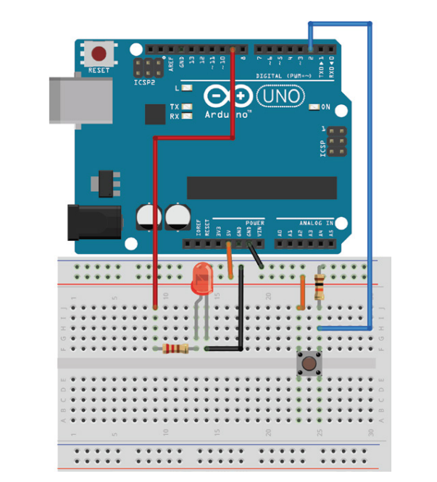

Circuit Setup:

Connect the LED's anode (longer leg) to a PWM-capable pin on the Arduino (e.g., pin 9).

Connect the LED's cathode (shorter leg) to one end of the 220-ohm resistor, and the other end of the resistor to the ground (GND) on the Arduino.

Connect one side of the pushbutton to 5V on the Arduino.

Connect the other side of the pushbutton to both the digital input pin on the Arduino (e.g., pin 2) and to one end of the 10k-ohm resistor. Connect the other end of the resistor to the ground (GND). This setup is known as a pull-down resistor configuration.

**Part 3**

If the LED is clear, you can see the outside structure. The larger piece of metal inside the LED usually connects to the common cathode.

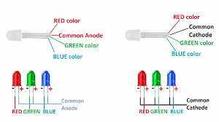

(Example picture),

OR,

Set the multimeter to the diode test setting.

Identify the common pin by testing each pin about the others. For a common-cathode LED, the common pin will be the one that, when connected to the negative (black) lead of the multimeter, will light up the corresponding LED color when the positive (red) lead touches the other pins.

**Wiring Changes:**

Connect the common cathode pin directly to the ground (GND) of your power supply or microcontroller.

Connect each R, G, and B pins to a digital output pin on the microcontroller through a resistor (usually between 220 to 470 ohms, but this can vary based on the LED’s specifications and the supply voltage).

Coding Changes:

